Experimenting with Optical Tomography to Teach Chess

Benjamin Vencill

Osvaldo Armas

1. Introduction

Chess is an incredibly popular board game, and one of the most widely played in the world. The rules of chess are simple; a player needs only to learn how to move their pieces and what the victory conditions are available. The strategy of the game, on the other hand, takes a lifetime to master. From hundreds of complex openings to sharp midgame tactics, getting a handle on the strategy of chess can be difficult for new players.

We propose a physical game system for teaching new players the ins and outs of chess strategy using a modified board. The board is an LCD monitor display outfitted with IR sensors used to map the physical pieces on the board using 2-D optical tomography. Using the collected board state information, the system provides the player with advice on next moves. Additionally, the system detects when a piece is picked up by a player and highlight all squares that are legal moves for that piece.

1. Design and Methodology

The chessboard is displayed on an LCD monitor. The monitor output is controlled by an Arduino RedBoard unit, detailed in [Appendix B]. Due to constraints on the Arduino’s output, the resolution of the LCD monitor is limited to 24 x 30 characters. Displayed characters are 8x8 pixels.

The frame for the board is constructed from laser-cut wood and cardboard. The frame is modeled using SolidWorks to fit the dimensions of the LCD and contain surrounding sensor bank, as well as the peripheral components, including the Arduino units, LCD power and control units.

A bank of 16 IR transmitter and receiver pairs line each of the sides of the board. The IR transmitter/receiver pairs are briefly described in Appendix B. In quick succession, each transmitter is sent a signal and shortly thereafter, the reflected signal is measured at each of the receivers. The system converts the raw optical readings into a representation of the board.

Using the board representation, the system determines which piece is selected (if any) and determines how to appropriately highlight squares on the board. If a piece is picked up, the system highlights legal squares for the piece to move into. If there is a strategy the player is practicing (for example, the Queen’s Gambit), the system will instead highlight the piece and square corresponding to the next correct move in the strategy’s sequence.

The board updates are communicated between Arduino units using an I2C protocol which can transmit up to 24 characters per message.

1. Project Implementation

The IR sensor boards were successfully fabricated and produced en masse. The sensor pairs successfully measured objects approaching the sensor and were able to work as a singular unit to produce a read of the board. Each row of 16 IR emitters is set to pulse, and receivers across the board record these signals, producing a 32x16 map of the board. Unfortunately, restrictions further limited what was work was able to be completed. Due to memory limitations and computational time, the IR data collected were reduced from 32x16 arrays per scan to 32x1 by reading only the emission directly across from the receiver. This severely limits the dimensionality and descriptiveness of the board model.

Due to time and resource constraints placed upon the team, the project was reduced in scope for this deliverable. The chessboard and chess game engine were omitted, and instead time was spent researching and testing the IR sensor and display setup.

The LCD monitor was successfully controlled by an Arduino unit to display our board representation. Data from the IR sensor bank is transferred to the LCD via I2C protocol [Appendix D], and a character representation of the data is produced and displayed.

1. Project Retrospective

Significant prototyping effort went towards designing the IR transmitter receiver bank. Designing the circuitry for correctly collecting information from all 32 sensor pairs, and correctly determining the layout of the board based on sensor information was a significant portion of the electronic component prototyping.

Additional effort went into designing the frame in AutoCAD. The design was made to factor in several units, including the LCD display, LCD power unit, LCD control, two Arduino units, and four IR sensor banks. A lot of the features of the board were eliminated through testing. A brace system for holding IR sensor boards in place was designed and deployed, but the cardboard material did not hold up well and ended up being scrapped. Elements relating to the chess game were also eliminated from the prototype designs early on, when the scope and focus of the project shifted.

Due to time constraint, it was decided to complete the project without many of the chess game elements. Dedicated prototyping for learning the IR sensor technology became the main pursuit of the project, as it is the novel technology being explored. Unfortunately, we were not able to get our larger-scale IR board to a functional state. The larger board was built to house a 32 IR pair system large enough to reading the ranks of a chessboard with two sensors to a square. The components for the board were fabricated and assembled, but the board didn’t make it past the debugging stage.

We learned an incredible amount during this project. As a team we had to improvise and make changes to our design when new constraints presented themselves. Our critical mistake was in scoping the project. We learned just how long physical circuits take to design and debug, and with this knowledge we will be better able to estimate how much time a project of this scale can and will take. While exciting, the project was too large an undertaking to be successfully complete all aspects within the given timeframe. With that being said, we learned how to adapt a plan and see it evolve into something successful. We were able to manage a lot of sweeping changes to our project’s design and execution. We improved our ability to fix and hack on the fly, and how to fail fast and iterate over and improve design ideas.

We spent a large part of this project prototyping the IR sensor bank. We applied knowledge gained from class to design the necessary circuits. We were initially very inexperienced with soldering circuit boards, and through this project had a large number of boards to fabricate, through which we learned important soldering skills as well as gained experience moving circuit designs from breadboard to circuit board. We went from being unable to consistently control where the solder went to being able to cleanly make solder bridges four and five across.

We learned how to control a large number of devices by using large multiplexers and de-multiplexers to select and read sensors at will. Additionally, we improved our device-oriented coding ability by writing code files for use in larger device systems. Through many long hours of working the multiplexer system, we learned debugging techniques for larger systems, especially the ability to isolate circuit elements to eliminate possible sources of error. We learned to double and triple check the order of the select bits to save major headaches later on.

1. Future Work

As a team, we are extremely excited about this project and hope to pursue this technology in earnest when we have the opportunity. We would like to see the completion of several omitted features, and propose several new features in addition.

1. Complete the chess board and game. Teaching chess was the initial motivation behind this project, and we would enjoy seeing the original purpose through. Several challenges are presented in pursuing this goal, including furnishing the actual game elements including the checkerboard, pieces, and game engine. The ability to sampling the board at a higher resolution than currently is available will be key to the game’s success.
2. Produce a higher resolution model. The addition of more sensor pairs, especially those not head-on with each other, will likely contribute to this goal.
3. Gain computing power. Incorporating embedded systems with the capability to process this higher resolution is essential. We are considering using Raspberry Pi units to provide this boost in computational muscle.
4. Incorporate machine learning into understanding our data. At its core, displaying our board state model onto the LCD a function mapping IR sensor data to discrete output characters and pixels. A neural network learner could produce this mapping with higher fidelity than our current model. Additionally, we would like to pursue research into using recurrent neural sequence models coupled with IR sensor data to predict physical movements. Our current prototype involves tracking an object as it crosses the board, and being able to project its trajectory using machine learning techniques would be exciting.
5. Finally implementing a Fourier Transformation model in order to allow all emitters to send a signal simultaneously, and using Fourier Decomposition to discern which signals were received.

**Appendix A**: Assembly Documentation

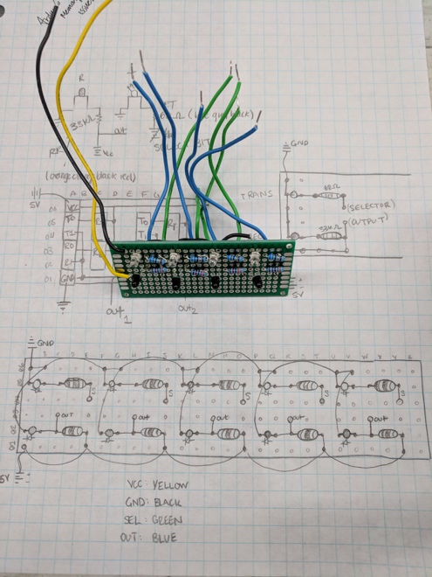

Figure . IR Sensor board and accompanying schematic.

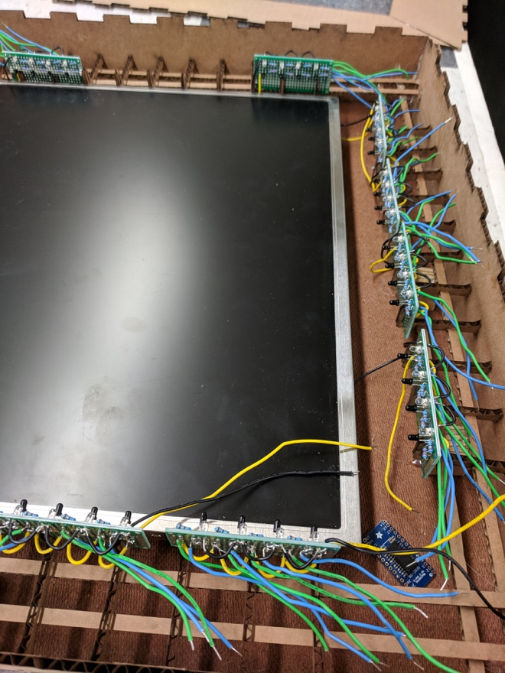

Figure . An early prototype of the board and frame. The cardboard arms didn’t hold!

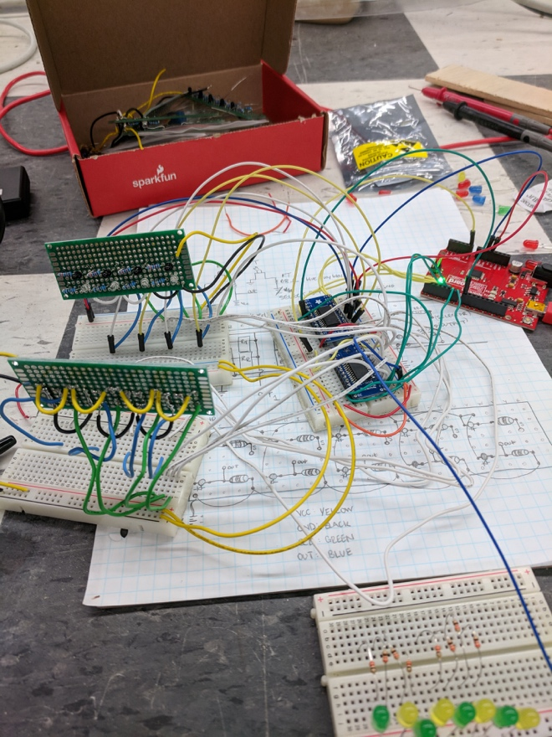

Figure . Our initial 4x2 IR board model. A sensor receives and reports on light signals from its partner emitter on the other side of the board.

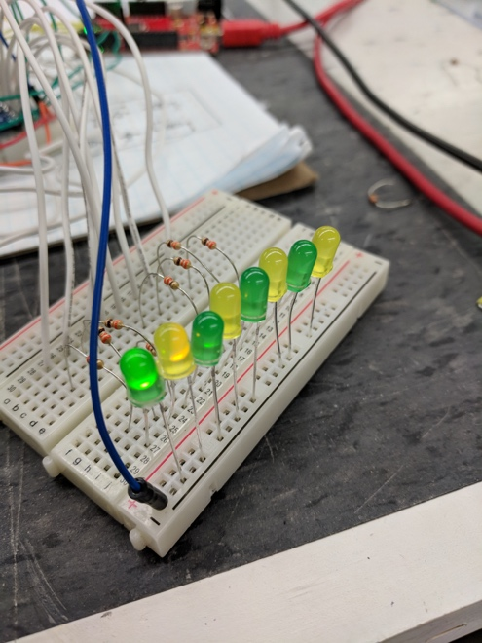

Figure . Debugging technique for testing multiplexing. Using visible light is easier than trying to see infrared!

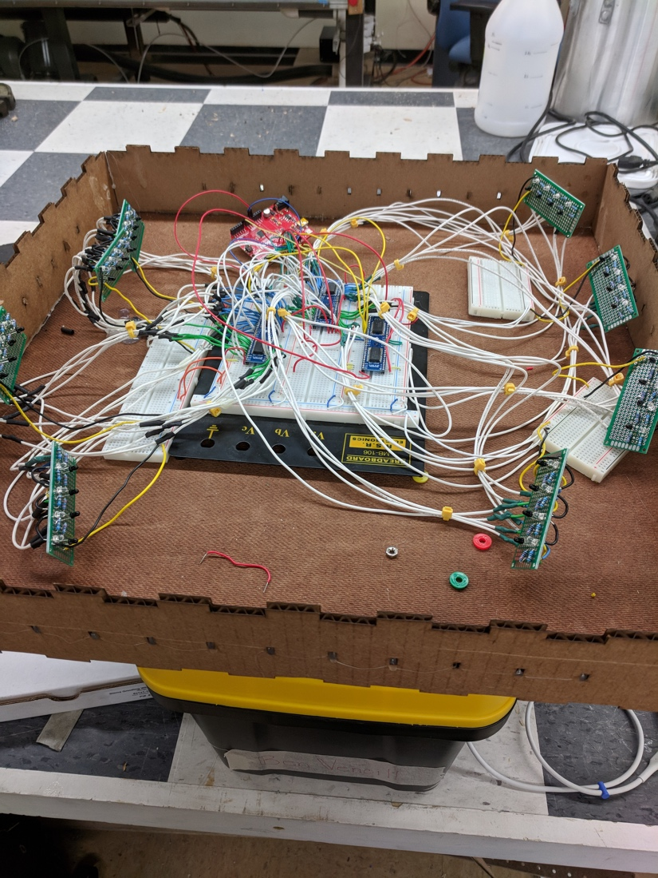

Figure . The large-board prototype contained a 16x2 bank of IR sensors. The mass in the center is the multiplexers and de-multiplexers used to control the 32 sensor pairs.

**Appendix B**: LCD Monitor Display

Code for the monitor display, as well as a setup tutorial, was provided by Nick Gammon here:

Gammon, Nick. “Gammon Forum : Electronics : Microprocessors : Arduino Uno Output to VGA Monitor.” *Written by Nick Gammon - 5K*, 24 Feb. 2016, [www.gammon.com.au/forum/?id=11608](http://www.gammon.com.au/forum/?id=11608).